**Understand logging in Python:**

Logging is use to track the execution of the program, which will be useful to trace when our code is breaking or giving warnings etc.

There are different levels of logging we can do in Python:   
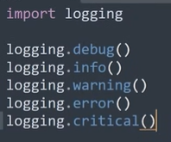

These are the levels and by default debug and info won’t display: 

We can set this level like this: 

If you want to output to a file: 

Logger file: 

Customize the logging file: 

Now output looks like this:   
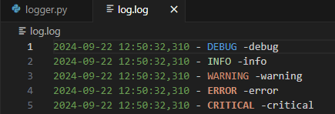

Wondering how we get to know “asctime” and others? Look:   
<https://docs.python.org/3/library/logging.html#logrecord-attributes>

How to include a variable in logs:   
output kind of like this: 

Logging Exceptions:   
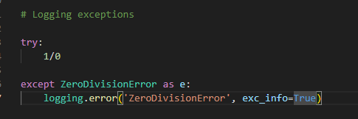

Output:

If you don’t know the Exception type that you might get then use this method.

Use **Exception** class in except and in the logger use **exception** function:   
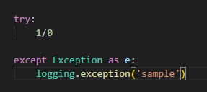

Output:   
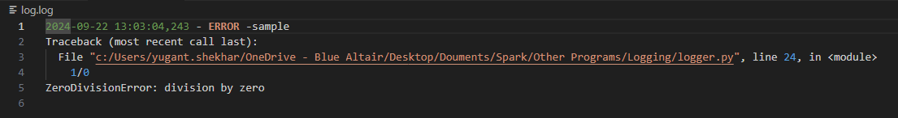

It will give the error message with its type.

**Custom Logger:**

Till now we were using the root logger which is created by default but in case we need our own logger then below is the process, created the logger with class/program name: 

Output: 

**Handler and Formatter:**

Handler is used when you want to specify the file to which you want to output your logs

Formatter is used to set the format of logs to your handler then you need to add this formatter to your handler and it will write logs to your desired location.

